**Name >> Muhammad Huzaifa**

**Roll No >> 04**

**Assignment 3**

**12th August 2023**

**Module 2 : Front End Development**

*Submission Requirements: Please upload your codes in PDF File on Google Classroom in the relevant Assignment section.*

*Note: Plagiarism is a serious violation. Zero marks will be awarded in case plagiarism is found.* You are required to perform the following tasks.

# Part 1:

* Apply a green text color to all <h2> elements.

**Solution:**



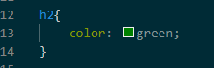



* Create a class called "highlight" and apply it to a paragraph (<p>) element to emphasize the text using a background color.

**Solution:**



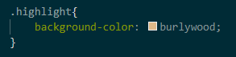



* Change the background color of the <body> to a color of your choice.

**Solution:**

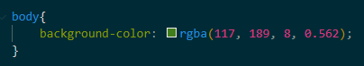

* Adjust the font size and color of the text within the .box element.

**Solution:**



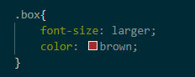



* Apply a different font family to the text within the .color element.

**Solution:**

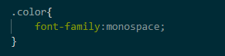



* Experiment with different values for the border-radius property within the .border class and observe the changes.

**Solution:**



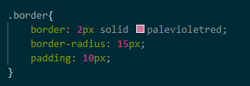



* Create a navigation menu using an ordered list (<ol> and <li> elements) and style the list items with a background color and padding.

**Solution:**

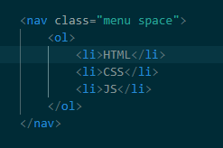

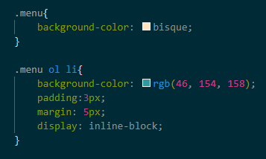



* Apply a custom class to a link (<a>) element and change the text decoration property.

**Solution:**

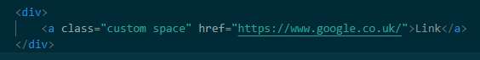

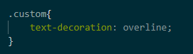



* Add a right border to all <h3> elements using the .border class.

**Solution:**

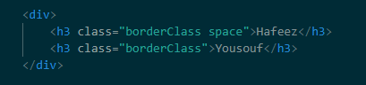

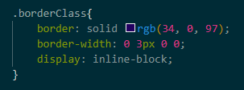



* Create a <div> element with the class "rounded-corner" and apply rounded corners to it using the border-radius property.

**Solution:**



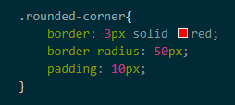



* Apply the .margin class to a block-level element and observe the margin space around it.

**Solution:**



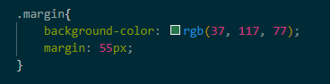



* Apply the .padding class to a block-level element and observe the padding space within it.

**Solution:**



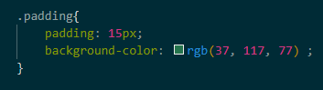



* Create a section with a <div> element and an <h4> element. Use the .textCenter class to center-align the text.

**Solution:**

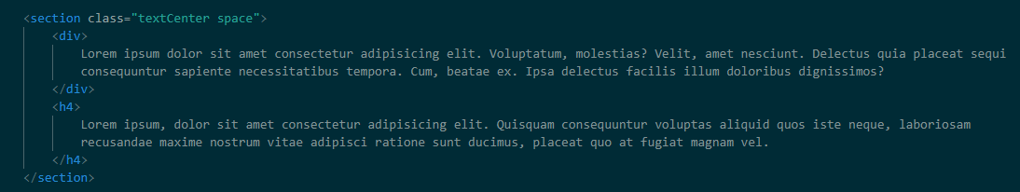

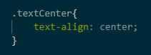



* Apply the .backgroundBlack class to a paragraph element and observe the background color change.

**Solution:**

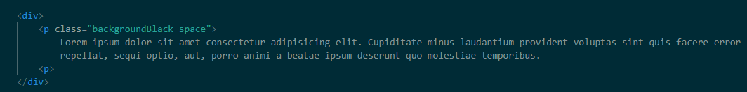



* Create a simple footer section at the bottom of the page using a <footer> element. Apply styles to make it stand out.

**Solution:**

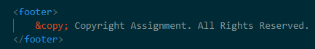

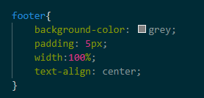



* Create a class called "inline-box" and apply it to a <div> element. Use the display property to make the element display as inline-block.

**Solution:**

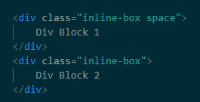

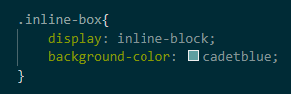

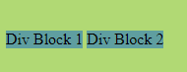

* Experiment with different values for the background-repeat property within the .backgroundImage class.

**Solution:**

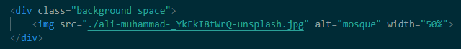

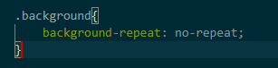



* Create a button using an <a> element and apply styles for its normal and hover states.

**Solution:**

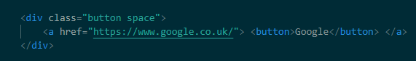

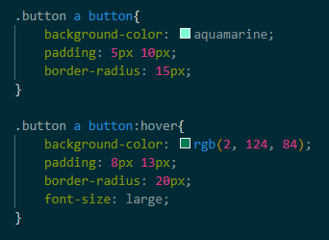

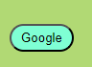--------------Hover----------> 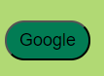

* Apply the .rtl class to a paragraph element to change the text direction to right-to-left.

**Solution:**



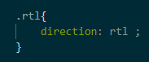



* Apply a gradient background to the .widget elements using the background property.

**Solution:**

